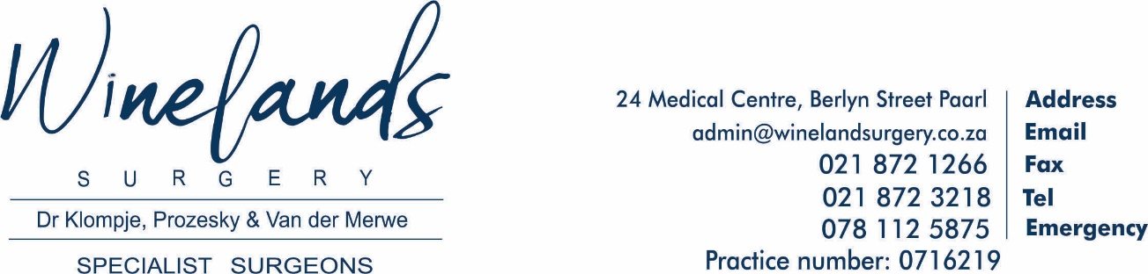
CONSENT TO FEES BEING CHARGED BY THIS PRACTICE
I, the undersigned, do hereby
- Acknowledge that I have been informed that this practice does not charge the rate that department of Health has unilaterally determined for doctors and which is known as Reference Price List (RPL).
- Confirm that I am aware that this practice fees can be up to 3x the RPL.
- This Practice charges Discovery Premier B Rate.
- Consultations will be charged at R652.60.
- In Hospital consultations and Procedures billed at Discovery Premier B rate.
- Patient is liable for a co payment which is determined by the insured rate for each plan and medical aid. An estimate amount will be provided on request.
- Accounts need to be settled within 30-days. We reserve the right to charge 2% interest as well as a R65 service fee per month on overdue accounts.

We have payment arrangements with all Discovery administrated Medical Schemes (Excluding Keycare Options), as well as Fedhealth and Polmed Medical Schemes.

Date:____________________________________

Name:___________________________________

Signature:________________________________

